Department of Computer Engineering

Academic Term: First Term 2023-24

# Class: T.E /Computer Sem – V / Software Engineering

|  |  |
| --- | --- |
| Practical No: | 9 |
| Title: | Designing Test Cases for Performing White Box Testing |
| Date of Performance: | 03/10/2023 |
| Roll No: | 9625 |
| Team Members: | Aditya Dhikale, Mohtashim Ali, Siddhant Murade  (9531) (9644) (9625) |

Rubrics for Evaluation:

|  |  |  |  |  |  |
| --- | --- | --- | --- | --- | --- |
| Sr. No | Performance Indicator | Excellent | Good | Below Average | Total Score |
| 1 | On time Completion & Submission (01) | 01 (On  Time ) | NA | 00 (Not on  Time) |  |
| 2 | Theory Understanding(02) | 02(Correct  ) | NA | 01 (Tried) |  |
| 3 | Content Quality (03) | 03(All used) | 02 (Partial) | 01 (rarely followed) |  |
| 4 | Post Lab Questions (04) | 04(done well) | 3 (Partially  Correct) | 2(submitted) |  |

Signature of the Teacher:

Department of Computer Engineering

Academic Term: First Term 2023-24

# Class: T.E /Computer Sem – V / Software Engineering

Signature of the Teacher:

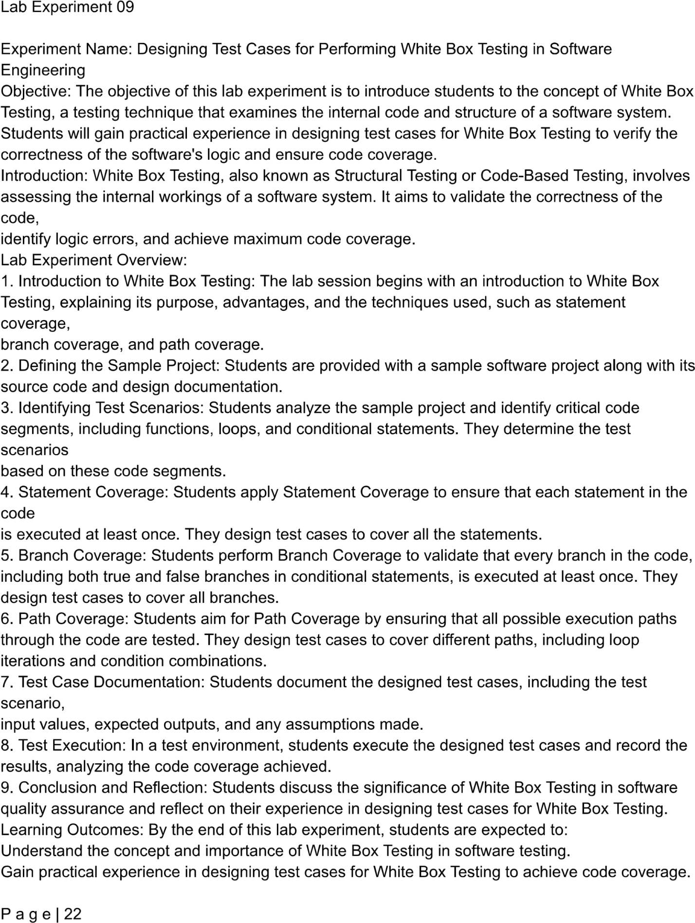

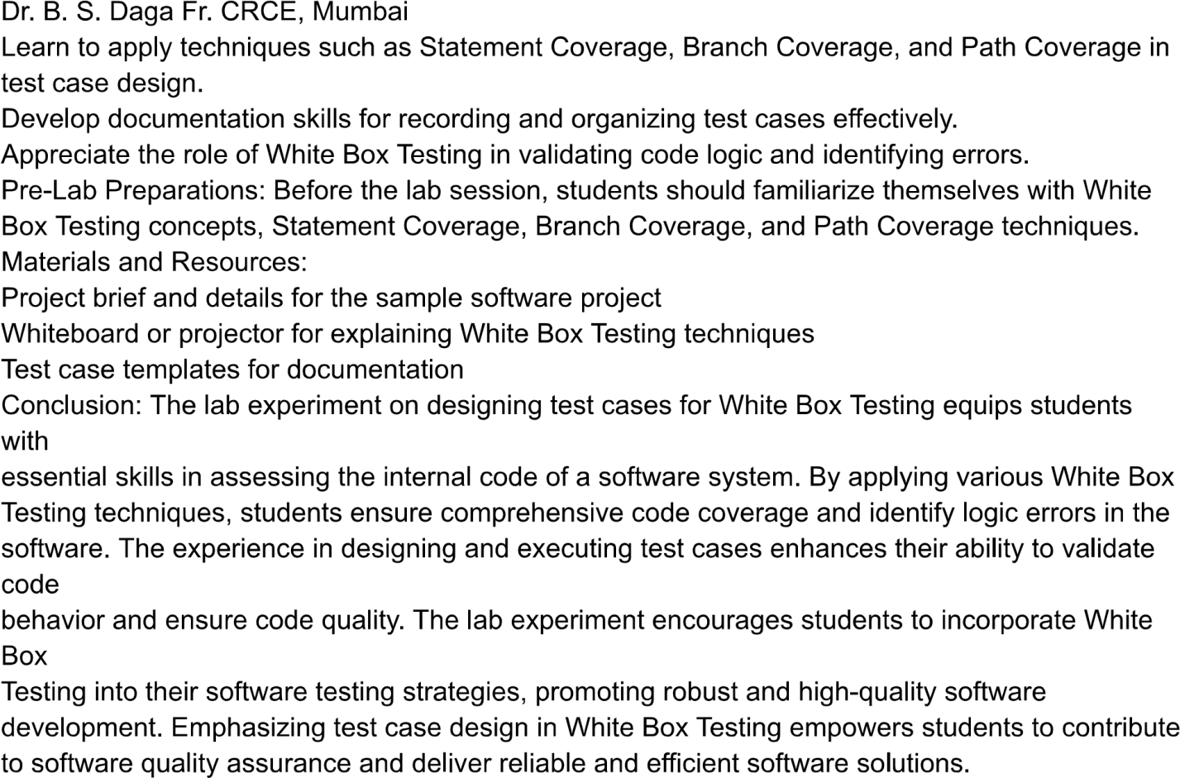

App.js

(A) function App() {

const[progress,setProgress] = useState(0)

return (

<>

<BrowserRouter>

(B) <Navbar setProgress={setProgress} />

(C) <LoadingBar height={3} color="#0d6efd" progress={progress} />

(D) <Slider />

<Routes>

(E) <Route path="/WildCart" element={<Itemsrow setProgress={setProgress} />} />

(F) <Route path="/search" element={<SearchItems setProgress={setProgress} />} />

(G) <Route path="/itemdetails/:productId" element={<ItemDetailsPage setProgress={setProgress} />} />

</Routes>

</BrowserRouter>

</>

(H) );

}

